**SKF KPI User Guide:-**

1. The bots currently run in unattended mode with no manual intervention.
2. 16635_SKF_Rpt_Prep bot scheduled at 6 am
3. 16635_SKF_KPI_Daily_Weekly_Main_Bot scheduled at 6:15 am
4. If the Main bot fails to generate the report till 6.45 am daily
   1. Open the Server
   2. Close all the opened files
   3. If current day is Monday :
      1. Place the last weeks Incident Report Weekly.xlsm file in the below path C:\SKF\Template
      2. Ensure that the Incident Report Daily.xlsm file in the path C:\SKF\Template is of Friday’s
      3. Close the VM
      4. Go to the Power Automate cloud
      5. 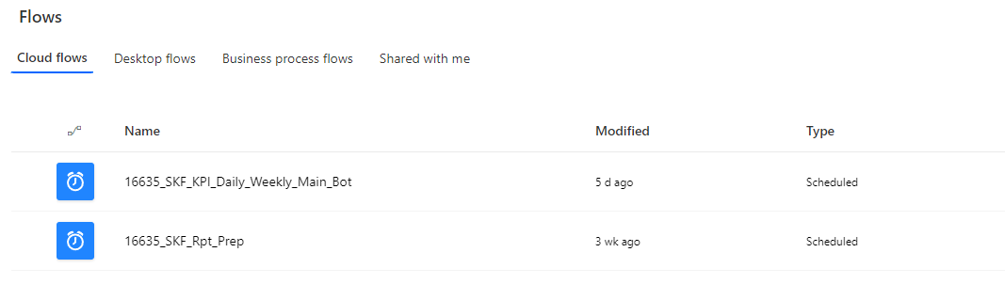
      6. Run the 16635_SKF_Rpt_Prep file
      7. After successful execution of the above , Run 16635_SKF_KPI_Daily_Weekly_Main_Bot
   4. If current day is not Monday:
      1. Place the previous day’s Incident Report Daily.xlsm file in the below path C:\SKF\Template
      2. Ensure that the current weeks Incident Report Weekly.xlsm is in the path C:\SKF\Template
      3. Close the VM
      4. Go to the Power Automate cloud
      5. Run the 16635_SKF_Rpt_Prep file
      6. After successful execution of the above , Run 16635_SKF_KPI_Daily_Weekly_Main_Bot
5. **KPI Report Folder Structure:-**

The below folders are present in C:\SKF path

* 1. Current_Day_Report:-
     1. Contains the Generated Current Day Report (weekly/daily)
  2. Email_Template:-
     1. Contains the body Templates for Daily & Weekly Report
  3. Macros:-
     1. Contains Daily & Weekly Macros
  4. SKF_Export:-
     1. Contains the Extracted Incident.xlsx file from PDXC
  5. Template:-
     1. Contains Incident Report Daily.xlsm , Incident Report Weekly
  6. Friday Report:-
     1. On every Saturday, the previous day’s (Friday’s ) Report will be moved to this folder.

1. Updations in Incident Report Daily:-
   1. The additional Workgroups and Towers can be added at the end in WorkGpVsTower Sheet
2. Updations in Incident Report Weekly:-
   1. The additional Workgroups and Towers can be added at the end in WorkGpVsTower (Old) Sheet